Uber Sales Analysis
1.Project Summary
- An end-to-end data analysis project focused on booking performance, cancellation trends, revenue patterns, vehicle contribution, seasonal insights, and estimated revenue loss using Power BI. The project identifies key operational gaps and provides data-driven business recommendations to improve completion rate and profitability.
2.Data Summary
- The dataset contains 150000 observations across 21 observations
- Key Features
  - Temporal Features (Date, Time)
  - Booking And ride details (Booking ID, Booking Status, Vehicle Type, Ride Distance, Booking Value)
  - Location Intelligence (Pickup Location, Drop Location)
  - Cancellation & ride failure metrics (Cancelled Rides by Customer, Reason for cancelling by customer, cancelled rides by driver, Driver Cancellation Reason, Incomplete rides, Incomplete rides reason)
  - Service Efficiency metrics (Avg VTAT, Avg CTAT)
  - Customer & driver Experience (Driver Ratings, Customer Ratings, Customer ID)
  - Payment & transactional behaviour (Payment method)
3.Analyse the dataset
- Understand the dataset through excel
  - Handling null values
The dataset contains null values in following columns
Date | 0
Time | 0
Booking_ID | 0
Booking_Status | 0
Customer_ID | 0
Vehicle_Type | 0
Pickup_Location | 0
Drop_Location | 0
Avg_VTAT | 10500
Avg_CTAT | 48000
Cancelled_Rides_by_Customer | 139500
Reason_for_cancelling_by_Customer | 139500
Cancelled_Rides_by_Driver | 123000
Driver_Cancellation_Reason | 123000
Incomplete_Rides | 141000
Incomplete_Rides_Reason | 141000
Booking_Value | 48000
Ride_Distance | 48000
Driver_Ratings | 57000
Customer_Rating | 57000
Payment_Method | 48000

3.1 Handled the null values
- Integer data types default value as 0, since as per the observation, the bookings except Completed other rides values are 0
- Categorical columns had huge number of null values.
  - We combined and done the feature engineering based on
all the null columns as (Cancelled_Rides_by_Customer, Reason_for_cancelling_by_Customer, Cancelled_Rides_by_Driver, Driver_Cancellation_Reason, Incomplete_Rides, Incomplete_Rides_Reason)
Trip_Status, Canelled_Ride_By and Cancelled_Reasons
3.2 Duplicate Values
- The dataset contains 1233 duplicated values
- Handled the null values in SQL (Completely removed through SQL query)
4. Import the dataset in SQL (MS-SQL)
- The dataset imported to MS-SQL for further analysis
5.Import the dataset into Jupyter notebook for Feature Selection
- Since we derived the new columns in Excel we removed unnecessary columns (Cancelled_Rides_by_Customer, Reason_for_cancelling_by_Customer, Cancelled_Rides_by_Driver, Driver_Cancellation_Reason, Incomplete_Rides, Incomplete_Rides_Reason)
- We done the column standardization
6. Import the clear dataset to the SQl

Data Analysis in SQl
6.1. Key Metrics
Metrics | Metric_Value
Total Bookings | 148767
Total Customer | 147579
Total Revenue | 51418660
Average Ride Distance | 26.00
Average Customer Rating | 4.40
6.2. Total Bookings by Booking Status
booking_status | total_bookings | overall_bookings | StatusRatioPercent
Completed | 92258 | 148767 | 62.02%
Cancelled by Driver | 26779 | 148767 | 18%
Cancelled by Customer | 10423 | 148767 | 7.01%
No Driver Found | 10401 | 148767 | 6.99%
Incomplete | 8906 | 148767 | 5.99%

6.3. Total Revenue by Booking Status
booking_status | booking_value | overall_revenue | StatusRatioPercent
Completed | 46886434 | 51418660 | 91.19%
Incomplete | 4532226 | 51418660 | 8.81%
Cancelled by Driver | 0 | 51418660 | 0%
No Driver Found | 0 | 51418660 | 0%
Cancelled by Customer | 0 | 51418660 | 0%

6.4. Total Bookings by Vehicle Type
vehicle_type | total_bookings | overall_bookings | StatusRatioPercent
Auto | 37114 | 148767 | 24.95%
Go Mini | 29541 | 148767 | 19.86%
Go Sedan | 26927 | 148767 | 18.10%
Bike | 22334 | 148767 | 15.01%
Premier Sedan | 17978 | 148767 | 12.08%
eBike | 10455 | 148767 | 7.03%
Uber XL | 4418 | 148767 | 2.97%

6.5 Total Revenue by Vehicle Type
vehicle_type | booking_value | overall_revenue | StatusRatioPercent
Auto | 12769097 | 51418660 | 24.83%
Go Mini | 10251162 | 51418660 | 19.94%
Go Sedan | 9298395 | 51418660 | 18.08%
Bike | 7764729 | 51418660 | 15.10%
Premier Sedan | 6230420 | 51418660 | 12.12%
eBike | 3587491 | 51418660 | 6.98%
Uber XL | 1517366 | 51418660 | 2.95%

6.7 Total Bookings by Pickup Location
pickup_location | total_bookings | overall_bookings | StatusRatioPercent
Khandsa | 941 | 148767 | 0.63%
Barakhamba Road | 938 | 148767 | 0.63%
Saket | 929 | 148767 | 0.62%
Badarpur | 914 | 148767 | 0.61%
AIIMS | 911 | 148767 | 0.61%
Madipur | 911 | 148767 | 0.61%
Pragati Maidan | 910 | 148767 | 0.61%
Mehrauli | 906 | 148767 | 0.61%
Dwarka Sector 21 | 906 | 148767 | 0.61%
Pataudi Chowk | 903 | 148767 | 0.61%
Tilak Nagar | 893 | 148767 | 0.60%
Shivaji Park | 893 | 148767 | 0.60%
Kanhaiya Nagar | 889 | 148767 | 0.60%
Udyog Vihar | 889 | 148767 | 0.60%
Greater Kailash | 885 | 148767 | 0.59%
Vishwavidyalaya | 884 | 148767 | 0.59%
Tagore Garden | 884 | 148767 | 0.59%
Jasola | 879 | 148767 | 0.59%
Jahangirpuri | 878 | 148767 | 0.59%
Ashok Park Main | 878 | 148767 | 0.59%
Nehru Place | 878 | 148767 | 0.59%
Inderlok | 877 | 148767 | 0.59%
Rajiv Nagar | 877 | 148767 | 0.59%
Noida Film City | 877 | 148767 | 0.59%
Jor Bagh | 874 | 148767 | 0.59%
Mansarovar Park | 874 | 148767 | 0.59%
ITO | 874 | 148767 | 0.59%
Nawada | 873 | 148767 | 0.59%
Subhash Chowk | 873 | 148767 | 0.59%
New Colony | 873 | 148767 | 0.59%
Malviya Nagar | 872 | 148767 | 0.59%
Samaypur Badli | 872 | 148767 | 0.59%
IGI Airport | 871 | 148767 | 0.59%
Lok Kalyan Marg | 870 | 148767 | 0.58%
GTB Nagar | 868 | 148767 | 0.58%
Gurgaon Railway Station | 868 | 148767 | 0.58%
Hauz Khas | 868 | 148767 | 0.58%
Panchsheel Park | 867 | 148767 | 0.58%
Karol Bagh | 867 | 148767 | 0.58%
Ambience Mall | 867 | 148767 | 0.58%
Chanakyapuri | 866 | 148767 | 0.58%
Rithala | 866 | 148767 | 0.58%
Vasant Kunj | 866 | 148767 | 0.58%
Shastri Park | 864 | 148767 | 0.58%
Ashram | 864 | 148767 | 0.58%
Rohini East | 862 | 148767 | 0.58%
Punjabi Bagh | 862 | 148767 | 0.58%
Keshav Puram | 862 | 148767 | 0.58%
India Gate | 862 | 148767 | 0.58%
Botanical Garden | 861 | 148767 | 0.58%
Greater Noida | 861 | 148767 | 0.58%
Badshahpur | 860 | 148767 | 0.58%
Aya Nagar | 860 | 148767 | 0.58%
DLF City Court | 859 | 148767 | 0.58%
Vaishali | 859 | 148767 | 0.58%
Shastri Nagar | 858 | 148767 | 0.58%
Mayur Vihar | 858 | 148767 | 0.58%
Model Town | 858 | 148767 | 0.58%
Ghitorni | 856 | 148767 | 0.58%
Subhash Nagar | 856 | 148767 | 0.58%
Basai Dhankot | 856 | 148767 | 0.58%
Tughlakabad | 856 | 148767 | 0.58%
Peeragarhi | 855 | 148767 | 0.57%
Saidulajab | 855 | 148767 | 0.57%
Chandni Chowk | 855 | 148767 | 0.57%
Sonipat | 854 | 148767 | 0.57%
Cyber Hub | 854 | 148767 | 0.57%
Ardee City | 854 | 148767 | 0.57%
Pulbangash | 853 | 148767 | 0.57%
Hero Honda Chowk | 851 | 148767 | 0.57%
Civil Lines Gurgaon | 851 | 148767 | 0.57%
Huda City Centre | 850 | 148767 | 0.57%
Anand Vihar | 850 | 148767 | 0.57%
Pitampura | 849 | 148767 | 0.57%
Indirapuram | 848 | 148767 | 0.57%
Patel Chowk | 848 | 148767 | 0.57%
Moti Nagar | 848 | 148767 | 0.57%
Sarai Kale Khan | 847 | 148767 | 0.57%
Kaushambi | 847 | 148767 | 0.57%
Adarsh Nagar | 847 | 148767 | 0.57%
RK Puram | 846 | 148767 | 0.57%
Rajouri Garden | 845 | 148767 | 0.57%
Sushant Lok | 845 | 148767 | 0.57%
Indraprastha | 844 | 148767 | 0.57%
Sarojini Nagar | 844 | 148767 | 0.57%
Ghaziabad | 844 | 148767 | 0.57%
Delhi Gate | 844 | 148767 | 0.57%
Sikanderpur | 843 | 148767 | 0.57%
Moolchand | 843 | 148767 | 0.57%
Jama Masjid | 842 | 148767 | 0.57%
Rohini | 842 | 148767 | 0.57%
Hauz Rani | 841 | 148767 | 0.57%
Sultanpur | 841 | 148767 | 0.57%
Bhiwadi | 841 | 148767 | 0.57%
Raj Nagar Extension | 840 | 148767 | 0.56%
Satguru Ram Singh Marg | 839 | 148767 | 0.56%
Janakpuri | 839 | 148767 | 0.56%
Narsinghpur | 838 | 148767 | 0.56%
Tis Hazari | 838 | 148767 | 0.56%
Azadpur | 838 | 148767 | 0.56%
Kadarpur | 838 | 148767 | 0.56%
DLF Phase 3 | 837 | 148767 | 0.56%
Akshardham | 836 | 148767 | 0.56%
New Delhi Railway Station | 836 | 148767 | 0.56%
Nirman Vihar | 836 | 148767 | 0.56%
Green Park | 836 | 148767 | 0.56%
South Extension | 835 | 148767 | 0.56%
INA Market | 835 | 148767 | 0.56%
Central Secretariat | 834 | 148767 | 0.56%
Panipat | 834 | 148767 | 0.56%
Sohna Road | 833 | 148767 | 0.56%
Dwarka Mor | 833 | 148767 | 0.56%
Udyog Bhawan | 833 | 148767 | 0.56%
Rohini West | 832 | 148767 | 0.56%
Udyog Vihar Phase 4 | 832 | 148767 | 0.56%
Kashmere Gate ISBT | 832 | 148767 | 0.56%
IMT Manesar | 830 | 148767 | 0.56%
Connaught Place | 829 | 148767 | 0.56%
Welcome | 828 | 148767 | 0.56%
Kashmere Gate | 828 | 148767 | 0.56%
Faridabad Sector 15 | 827 | 148767 | 0.56%
Karkarduma | 827 | 148767 | 0.56%
Rajiv Chowk | 826 | 148767 | 0.56%
Chhatarpur | 825 | 148767 | 0.55%
Seelampur | 825 | 148767 | 0.55%
Preet Vihar | 825 | 148767 | 0.55%
Noida Sector 62 | 825 | 148767 | 0.55%
Khan Market | 824 | 148767 | 0.55%
Netaji Subhash Place | 824 | 148767 | 0.55%
Anand Vihar ISBT | 823 | 148767 | 0.55%
IIT Delhi | 823 | 148767 | 0.55%
Gurgaon Sector 56 | 823 | 148767 | 0.55%
Mundka | 823 | 148767 | 0.55%
Meerut | 823 | 148767 | 0.55%
Kherki Daula Toll | 822 | 148767 | 0.55%
Vatika Chowk | 822 | 148767 | 0.55%
IFFCO Chowk | 822 | 148767 | 0.55%
Manesar | 822 | 148767 | 0.55%
Govindpuri | 821 | 148767 | 0.55%
Noida Extension | 821 | 148767 | 0.55%
Lal Quila | 821 | 148767 | 0.55%
Vidhan Sabha | 820 | 148767 | 0.55%
Vinobapuri | 820 | 148767 | 0.55%
Kirti Nagar | 819 | 148767 | 0.55%
Lajpat Nagar | 819 | 148767 | 0.55%
Gurgaon Sector 29 | 818 | 148767 | 0.55%
Bhikaji Cama Place | 818 | 148767 | 0.55%
Yamuna Bank | 818 | 148767 | 0.55%
Paschim Vihar | 817 | 148767 | 0.55%
Uttam Nagar | 817 | 148767 | 0.55%
Okhla | 817 | 148767 | 0.55%
Jhilmil | 816 | 148767 | 0.55%
Paharganj | 816 | 148767 | 0.55%
Shahdara | 816 | 148767 | 0.55%
Saket A Block | 815 | 148767 | 0.55%
Maidan Garhi | 815 | 148767 | 0.55%
Qutub Minar | 814 | 148767 | 0.55%
Munirka | 814 | 148767 | 0.55%
Palam Vihar | 813 | 148767 | 0.55%
Gwal Pahari | 810 | 148767 | 0.54%
Golf Course Road | 808 | 148767 | 0.54%
Sadar Bazar Gurgaon | 808 | 148767 | 0.54%
MG Road | 808 | 148767 | 0.54%
IGNOU Road | 807 | 148767 | 0.54%
Ramesh Nagar | 806 | 148767 | 0.54%
Arjangarh | 805 | 148767 | 0.54%
Old Gurgaon | 804 | 148767 | 0.54%
Kalkaji | 795 | 148767 | 0.53%
Mandi House | 795 | 148767 | 0.53%
Noida Sector 18 | 794 | 148767 | 0.53%
Dilshad Garden | 793 | 148767 | 0.53%
Bahadurgarh | 790 | 148767 | 0.53%
Chirag Delhi | 786 | 148767 | 0.53%
Laxmi Nagar | 786 | 148767 | 0.53%
Ashok Vihar | 785 | 148767 | 0.53%
Ghitorni Village | 778 | 148767 | 0.52%

6.8 Total Revenue by Pickup Location
pickup_location | booking_value | overall_revenue | StatusRatioPercent
Barakhamba Road | 338800 | 51418660 | 0.66%
Khandsa | 335571 | 51418660 | 0.65%
Pataudi Chowk | 325783 | 51418660 | 0.63%
AIIMS | 323639 | 51418660 | 0.63%
Subhash Chowk | 323578 | 51418660 | 0.63%
Badarpur | 322290 | 51418660 | 0.63%
Inderlok | 321872 | 51418660 | 0.63%
Tughlakabad | 320973 | 51418660 | 0.62%
Udyog Vihar | 319401 | 51418660 | 0.62%
Greater Noida | 319232 | 51418660 | 0.62%
ITO | 318878 | 51418660 | 0.62%
Subhash Nagar | 318462 | 51418660 | 0.62%
Madipur | 317414 | 51418660 | 0.62%
IMT Manesar | 317407 | 51418660 | 0.62%
Botanical Garden | 317216 | 51418660 | 0.62%
Mayur Vihar | 316913 | 51418660 | 0.62%
Kanhaiya Nagar | 315926 | 51418660 | 0.61%
Ashok Park Main | 315538 | 51418660 | 0.61%
Tagore Garden | 315160 | 51418660 | 0.61%
Saidulajab | 313847 | 51418660 | 0.61%
Basai Dhankot | 313836 | 51418660 | 0.61%
Dwarka Sector 21 | 313637 | 51418660 | 0.61%
Shastri Nagar | 313283 | 51418660 | 0.61%
Tilak Nagar | 311360 | 51418660 | 0.61%
Peeragarhi | 311258 | 51418660 | 0.61%
Jama Masjid | 310946 | 51418660 | 0.60%
Vishwavidyalaya | 310799 | 51418660 | 0.60%
Gurgaon Railway Station | 310071 | 51418660 | 0.60%
Shivaji Park | 309531 | 51418660 | 0.60%
Panchsheel Park | 308740 | 51418660 | 0.60%
Okhla | 308285 | 51418660 | 0.60%
Sultanpur | 307765 | 51418660 | 0.60%
Lok Kalyan Marg | 307523 | 51418660 | 0.60%
Noida Film City | 307107 | 51418660 | 0.60%
New Colony | 307072 | 51418660 | 0.60%
Hauz Khas | 306900 | 51418660 | 0.60%
Ashram | 306816 | 51418660 | 0.60%
Rithala | 306512 | 51418660 | 0.60%
Huda City Centre | 306498 | 51418660 | 0.60%
Jasola | 306318 | 51418660 | 0.60%
Jahangirpuri | 306112 | 51418660 | 0.60%
India Gate | 306084 | 51418660 | 0.60%
Samaypur Badli | 304890 | 51418660 | 0.59%
Malviya Nagar | 304646 | 51418660 | 0.59%
Anand Vihar ISBT | 304382 | 51418660 | 0.59%
Kaushambi | 303686 | 51418660 | 0.59%
DLF City Court | 302980 | 51418660 | 0.59%
Sohna Road | 302609 | 51418660 | 0.59%
RK Puram | 302297 | 51418660 | 0.59%
Keshav Puram | 302290 | 51418660 | 0.59%
Ghitorni | 302113 | 51418660 | 0.59%
Welcome | 302039 | 51418660 | 0.59%
Tis Hazari | 301632 | 51418660 | 0.59%
Jor Bagh | 301148 | 51418660 | 0.59%
Vasant Kunj | 301051 | 51418660 | 0.59%
Ardee City | 300610 | 51418660 | 0.58%
Dwarka Mor | 300086 | 51418660 | 0.58%
Indraprastha | 299992 | 51418660 | 0.58%
Hero Honda Chowk | 298664 | 51418660 | 0.58%
Pragati Maidan | 298663 | 51418660 | 0.58%
Sarai Kale Khan | 298317 | 51418660 | 0.58%
Mehrauli | 298294 | 51418660 | 0.58%
Rohini West | 298272 | 51418660 | 0.58%
Punjabi Bagh | 297325 | 51418660 | 0.58%
Nirman Vihar | 297075 | 51418660 | 0.58%
Sarojini Nagar | 296770 | 51418660 | 0.58%
Ghaziabad | 296664 | 51418660 | 0.58%
Raj Nagar Extension | 296617 | 51418660 | 0.58%
Rajiv Chowk | 296484 | 51418660 | 0.58%
Delhi Gate | 296306 | 51418660 | 0.58%
Cyber Hub | 296302 | 51418660 | 0.58%
Paharganj | 296278 | 51418660 | 0.58%
Connaught Place | 296122 | 51418660 | 0.58%
Ambience Mall | 295773 | 51418660 | 0.58%
Chanakyapuri | 294880 | 51418660 | 0.57%
IGI Airport | 294861 | 51418660 | 0.57%
Civil Lines Gurgaon | 294521 | 51418660 | 0.57%
Yamuna Bank | 293676 | 51418660 | 0.57%
IGNOU Road | 293477 | 51418660 | 0.57%
Karol Bagh | 292910 | 51418660 | 0.57%
South Extension | 292781 | 51418660 | 0.57%
Panipat | 292670 | 51418660 | 0.57%
Sushant Lok | 292503 | 51418660 | 0.57%
Bhiwadi | 292377 | 51418660 | 0.57%
Saket | 292355 | 51418660 | 0.57%
Kherki Daula Toll | 292062 | 51418660 | 0.57%
Greater Kailash | 291478 | 51418660 | 0.57%
Pulbangash | 291364 | 51418660 | 0.57%
Satguru Ram Singh Marg | 290957 | 51418660 | 0.57%
Rohini | 290169 | 51418660 | 0.56%
Badshahpur | 289876 | 51418660 | 0.56%
Azadpur | 289830 | 51418660 | 0.56%
Rohini East | 289792 | 51418660 | 0.56%
Mundka | 289588 | 51418660 | 0.56%
Gurgaon Sector 56 | 289453 | 51418660 | 0.56%
Rajiv Nagar | 289280 | 51418660 | 0.56%
Anand Vihar | 289224 | 51418660 | 0.56%
Nehru Place | 289110 | 51418660 | 0.56%
Dilshad Garden | 288751 | 51418660 | 0.56%
GTB Nagar | 288674 | 51418660 | 0.56%
Rajouri Garden | 288385 | 51418660 | 0.56%
Kadarpur | 288251 | 51418660 | 0.56%
Mansarovar Park | 287909 | 51418660 | 0.56%
DLF Phase 3 | 287834 | 51418660 | 0.56%
Arjangarh | 287322 | 51418660 | 0.56%
Ramesh Nagar | 287209 | 51418660 | 0.56%
Central Secretariat | 287170 | 51418660 | 0.56%
Moti Nagar | 287092 | 51418660 | 0.56%
Uttam Nagar | 286966 | 51418660 | 0.56%
Chandni Chowk | 286748 | 51418660 | 0.56%
Udyog Vihar Phase 4 | 286730 | 51418660 | 0.56%
Indirapuram | 286617 | 51418660 | 0.56%
Janakpuri | 286592 | 51418660 | 0.56%
Hauz Rani | 285339 | 51418660 | 0.55%
Aya Nagar | 284990 | 51418660 | 0.55%
Shastri Park | 284306 | 51418660 | 0.55%
Khan Market | 284131 | 51418660 | 0.55%
Kashmere Gate ISBT | 283779 | 51418660 | 0.55%
Kashmere Gate | 283732 | 51418660 | 0.55%
Noida Sector 18 | 283518 | 51418660 | 0.55%
Jhilmil | 283107 | 51418660 | 0.55%
Noida Extension | 283099 | 51418660 | 0.55%
New Delhi Railway Station | 282988 | 51418660 | 0.55%
Pitampura | 282808 | 51418660 | 0.55%
INA Market | 282599 | 51418660 | 0.55%
Kalkaji | 282530 | 51418660 | 0.55%
Paschim Vihar | 281249 | 51418660 | 0.55%
Meerut | 280668 | 51418660 | 0.55%
Gwal Pahari | 280445 | 51418660 | 0.55%
Vaishali | 280398 | 51418660 | 0.55%
Seelampur | 280333 | 51418660 | 0.55%
Manesar | 280089 | 51418660 | 0.54%
Preet Vihar | 279686 | 51418660 | 0.54%
IFFCO Chowk | 278615 | 51418660 | 0.54%
Lajpat Nagar | 278501 | 51418660 | 0.54%
Udyog Bhawan | 278494 | 51418660 | 0.54%
Ashok Vihar | 278312 | 51418660 | 0.54%
Kirti Nagar | 277762 | 51418660 | 0.54%
Golf Course Road | 277758 | 51418660 | 0.54%
Noida Sector 62 | 277654 | 51418660 | 0.54%
Gurgaon Sector 29 | 277314 | 51418660 | 0.54%
IIT Delhi | 277293 | 51418660 | 0.54%
Green Park | 277180 | 51418660 | 0.54%
Moolchand | 276722 | 51418660 | 0.54%
Model Town | 276402 | 51418660 | 0.54%
Patel Chowk | 274361 | 51418660 | 0.53%
Sikanderpur | 274189 | 51418660 | 0.53%
Nawada | 274117 | 51418660 | 0.53%
Munirka | 274005 | 51418660 | 0.53%
Palam Vihar | 273890 | 51418660 | 0.53%
Adarsh Nagar | 273604 | 51418660 | 0.53%
Maidan Garhi | 273114 | 51418660 | 0.53%
Shahdara | 273023 | 51418660 | 0.53%
Saket A Block | 272672 | 51418660 | 0.53%
Lal Quila | 272624 | 51418660 | 0.53%
MG Road | 272160 | 51418660 | 0.53%
Sonipat | 271599 | 51418660 | 0.53%
Karkarduma | 271447 | 51418660 | 0.53%
Govindpuri | 271354 | 51418660 | 0.53%
Narsinghpur | 271178 | 51418660 | 0.53%
Vidhan Sabha | 270820 | 51418660 | 0.53%
Bahadurgarh | 270763 | 51418660 | 0.53%
Bhikaji Cama Place | 269763 | 51418660 | 0.52%
Sadar Bazar Gurgaon | 269682 | 51418660 | 0.52%
Qutub Minar | 269258 | 51418660 | 0.52%
Mandi House | 268995 | 51418660 | 0.52%
Laxmi Nagar | 266609 | 51418660 | 0.52%
Netaji Subhash Place | 264983 | 51418660 | 0.52%
Chirag Delhi | 264599 | 51418660 | 0.51%
Chhatarpur | 264329 | 51418660 | 0.51%
Old Gurgaon | 264060 | 51418660 | 0.51%
Ghitorni Village | 262951 | 51418660 | 0.51%
Faridabad Sector 15 | 258947 | 51418660 | 0.50%
Akshardham | 258068 | 51418660 | 0.50%
Vinobapuri | 252744 | 51418660 | 0.49%
Vatika Chowk | 250777 | 51418660 | 0.49%

6.9 Total Cancelled Bookings by cancelled source
cancelled_ride_by | total_bookings | overall_bookings | StatusRatioPercent
Driver | 26779 | 56509 | 47.39%
Customer | 10423 | 56509 | 18.44%
No Driver Found | 10401 | 56509 | 18.41%
Incompleted Ride | 8906 | 56509 | 15.76%

6.10 Total Cancellations based on cancelled by and reasons
canelled_ride_by | cancelled_reasons | total_bookings | overall_bookings | Proportion
No Driver Found | No Driver Found | 10401 | 56509 | 18.41%
Driver | Customer related issueDriver | 6780 | 56509 | 12%
Driver | The customer was coughing/sickDriver | 6697 | 56509 | 11.85%
Driver | Personal & Car related issuesDriver | 6676 | 56509 | 11.81%
Driver | More than permitted people in thereDriver | 6626 | 56509 | 11.73%
Incompleted Ride | Customer DemandIncompleted Ride | 3011 | 56509 | 5.33%
Incompleted Ride | Vehicle BreakdownIncompleted Ride | 2981 | 56509 | 5.28%
Incompleted Ride | Other IssueIncompleted Ride | 2914 | 56509 | 5.16%
Customer | Wrong AddressCustomer | 2345 | 56509 | 4.15%
Customer | Change of plansCustomer | 2337 | 56509 | 4.14%
Customer | Driver is not moving towards pickup locationCustomer | 2318 | 56509 | 4.10%
Customer | Driver asked to cancelCustomer | 2279 | 56509 | 4.03%
Customer | AC is not workingCustomer | 1144 | 56509 | 2.02%

6.11 Total Revenue by Payment Method
payment_method | booking_value | overall_revenue | Proportion
UPI | 23164432 | 51418660 | 45.05%
Cash | 12785182 | 51418660 | 24.86%
Uber Wallet | 6152031 | 51418660 | 11.96%
Credit Card | 5171931 | 51418660 | 10.06%
Debit Card | 4145084 | 51418660 | 8.06%
Trip Cancelled | 0 | 51418660 | 0%

6.12 Estimated Revenue Loss
Estimated_revenue_loss
11768007

vehicle_type | Estimated_revenue_loss | Contribution
Auto | 3781331 | 32.13
Go Mini | 2558816 | 21.74
Go Sedan | 2243905 | 19.07
Bike | 1621563 | 13.78
Premier Sedan | 1065181 | 9.05
eBike | 414013 | 3.52
Uber XL | 83198 | 0.71

6.13 Pickup and drop location-wise cancellation rates
pickup_location | drop_location | cancelled_count | total_cancelled | Cancellation_rates
Satguru Ram Singh Marg | Khandsa | 10 | 56509 | 0.02%
Jama Masjid | New Colony | 9 | 56509 | 0.02%
Ghaziabad | Badshahpur | 9 | 56509 | 0.02%
Akshardham | RK Puram | 9 | 56509 | 0.02%
Lajpat Nagar | Jahangirpuri | 9 | 56509 | 0.02%
Noida Extension | Karol Bagh | 9 | 56509 | 0.02%
Kalkaji | Nehru Place | 8 | 56509 | 0.01%
Vinobapuri | Nehru Place | 8 | 56509 | 0.01%
Barakhamba Road | Sarojini Nagar | 8 | 56509 | 0.01%
Pitampura | Nehru Place | 8 | 56509 | 0.01%
Subhash Chowk | Raj Nagar Extension | 8 | 56509 | 0.01%
Uttam Nagar | Kherki Daula Toll | 8 | 56509 | 0.01%
Chhatarpur | Hauz Khas | 8 | 56509 | 0.01%
Mundka | ITO | 8 | 56509 | 0.01%
Jahangirpuri | Connaught Place | 8 | 56509 | 0.01%
Dwarka Sector 21 | Rohini | 8 | 56509 | 0.01%
Cyber Hub | Ardee City | 8 | 56509 | 0.01%
Akshardham | Hauz Khas | 8 | 56509 | 0.01%
Jor Bagh | Rohini East | 8 | 56509 | 0.01%
Vasant Kunj | Hauz Khas | 8 | 56509 | 0.01%
Akshardham | Kherki Daula Toll | 8 | 56509 | 0.01%
Lal Quila | Kaushambi | 8 | 56509 | 0.01%
Pragati Maidan | Kashmere Gate ISBT | 8 | 56509 | 0.01%
Keshav Puram | Moolchand | 8 | 56509 | 0.01%
Manesar | Subhash Nagar | 8 | 56509 | 0.01%

6.14 Trend Analysis
6.14.1 Quarter wise
a. Revenue
Quarter | revenue | overall_revenue | contribution
1 | 13036238 | 51418660 | 25.35%
4 | 12899550 | 51418660 | 25.09%
2 | 12812632 | 51418660 | 24.92%
3 | 12670240 | 51418660 | 24.64%

b. Booking Volume
Quarter | booking_volume | Overall_booking_Volume | Contribution
1 | 37427 | 148767 | 25.16%
3 | 37405 | 148767 | 25.14%
2 | 37179 | 148767 | 24.99%
4 | 36756 | 148767 | 24.71%

c. Cancellation
Quarter | booking_volume | Overall_booking_Volume | Contribution
3 | 14383 | 56509 | 25.45%
1 | 14201 | 56509 | 25.13%
2 | 14026 | 56509 | 24.82%
4 | 13899 | 56509 | 24.60%

6.14.2 Month
a. Revenue
Month | month_name | revenue | overall_revenue | contribution
1 | January | 4408364 | 51418660 | 8.57%
2 | February | 4074238 | 51418660 | 7.92%
3 | March | 4553636 | 51418660 | 8.86%
4 | April | 4232151 | 51418660 | 8.23%
5 | May | 4291467 | 51418660 | 8.35%
6 | June | 4289014 | 51418660 | 8.34%
7 | July | 4330388 | 51418660 | 8.42%
8 | August | 4204899 | 51418660 | 8.18%
9 | September | 4134953 | 51418660 | 8.04%
10 | October | 4359970 | 51418660 | 8.48%
11 | November | 4284469 | 51418660 | 8.33%
12 | December | 4255111 | 51418660 | 8.28%

b. Booking Volume
Month | month_name | booking_volume | Overall_booking_Volume | Contribution
1 | January | 12855 | 148767 | 8.64%
2 | February | 11897 | 148767 | 8%
3 | March | 12675 | 148767 | 8.52%
4 | April | 12135 | 148767 | 8.16%
5 | May | 12701 | 148767 | 8.54%
6 | June | 12343 | 148767 | 8.30%
7 | July | 12793 | 148767 | 8.60%
8 | August | 12507 | 148767 | 8.41%
9 | September | 12105 | 148767 | 8.14%
10 | October | 12472 | 148767 | 8.38%
11 | November | 12225 | 148767 | 8.22%
12 | December | 12059 | 148767 | 8.11%

c. Cancellations
month_name | booking_volume | Overall_booking_Volume | Contribution
January | 4906 | 56509 | 8.68%
February | 4548 | 56509 | 8.05%
March | 4747 | 56509 | 8.40%
April | 4541 | 56509 | 8.04%
May | 4840 | 56509 | 8.57%
June | 4645 | 56509 | 8.22%
July | 4930 | 56509 | 8.72%
August | 4804 | 56509 | 8.50%
September | 4649 | 56509 | 8.23%
October | 4667 | 56509 | 8.26%
November | 4671 | 56509 | 8.27%
December | 4561 | 56509 | 8.07%

6.14.3 Day
a. Revenue
Days | Day_name | revenue | overall_revenue | contribution
1 | Sunday | 9544887 | 51418660 | 18.56%
7 | Saturday | 9489788 | 51418660 | 18.46%
6 | Friday | 6630321 | 51418660 | 12.89%
4 | Wednesday | 6531307 | 51418660 | 12.70%
5 | Thursday | 6496934 | 51418660 | 12.64%
3 | Tuesday | 6365786 | 51418660 | 12.38%
2 | Monday | 6359637 | 51418660 | 12.37%

B. Booking Volume
Days | Day_name | booking_volume | Overall_booking_Volume | Contribution
2 | Monday | 21454 | 148767 | 14.42%
7 | Saturday | 21354 | 148767 | 14.35%
4 | Wednesday | 21246 | 148767 | 14.28%
3 | Tuesday | 21228 | 148767 | 14.27%
6 | Friday | 21226 | 148767 | 14.27%
1 | Sunday | 21218 | 148767 | 14.26%
5 | Thursday | 21041 | 148767 | 14.14%

c. Cancellations
Days | Day_name | booking_volume | Overall_booking_Volume | Contribution
2 | Monday | 8251 | 56509 | 14.60%
3 | Tuesday | 8161 | 56509 | 14.44%
6 | Friday | 8077 | 56509 | 14.29%
4 | Wednesday | 8042 | 56509 | 14.23%
7 | Saturday | 8028 | 56509 | 14.21%
1 | Sunday | 8009 | 56509 | 14.17%
5 | Thursday | 7941 | 56509 | 14.05%

6.15 Time Segment
6.15.1 Revenue
time_segment | revenue | overall_revenue | contribution
Evening | 16898370 | 51418660 | 32.86%
Afternoon | 16533381 | 51418660 | 32.15%
Morning | 14738298 | 51418660 | 28.66%
Night | 3248611 | 51418660 | 6.32%

6.15.2 Booking Volume
time_segment | booking_volume | Overall_booking_Volume | Contribution
Evening | 48952 | 148767 | 32.91%
Afternoon | 48002 | 148767 | 32.27%
Morning | 42329 | 148767 | 28.45%
Night | 9484 | 148767 | 6.38%

6.15.3 Cancellation
time_segment | booking_volume | Overall_booking_Volume | Contribution
Evening | 18605 | 56509 | 32.92%
Afternoon | 18316 | 56509 | 32.41%
Morning | 16009 | 56509 | 28.33%
Night | 3579 | 56509 | 6.33%

6.16 Location Cluster Based on No Driver Found
No_driver_freq | Segments | Total_Cities
Mid Frequency | 51 to 65 | 121
High Frequency | Above 65 | 32
Low Frequency | 35 to 50 | 23

20.Location Cluster Based on Incomplete
Incomplete_freq | Segments | Total_Cities
Mid Frequency | 46 to 60 | 118
Low Frequency | 30 to 45 | 42
High Frequency | Above 60 | 16

Creating Dashboard
With Power BI we created an interactive dashboard to understand visually
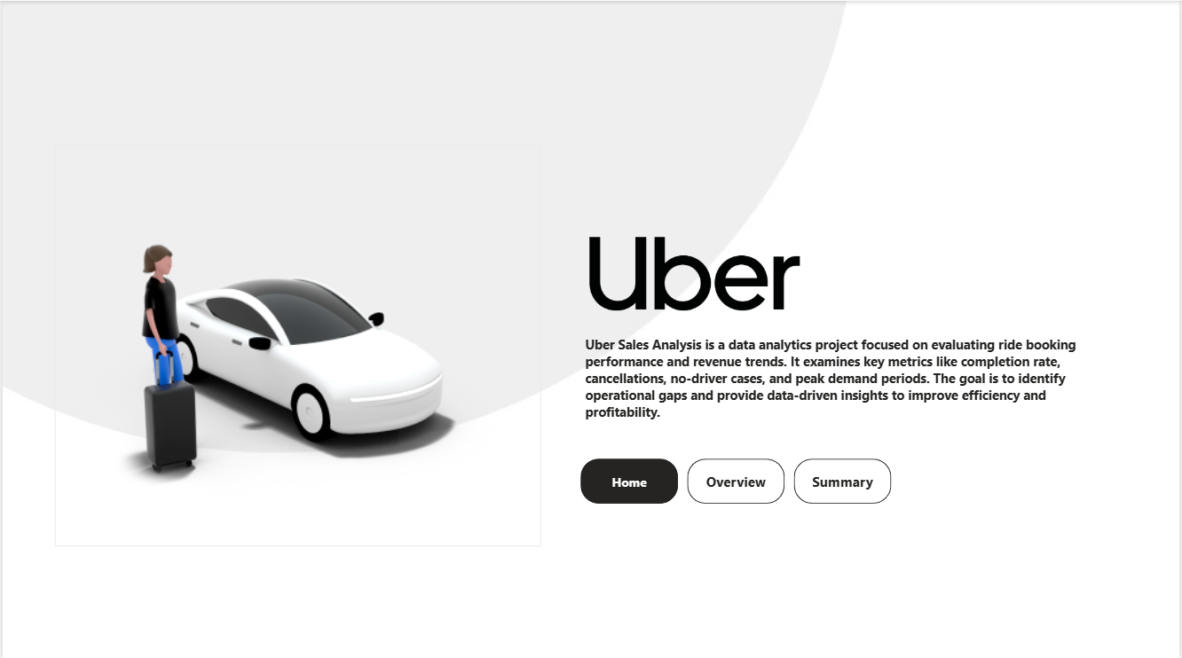
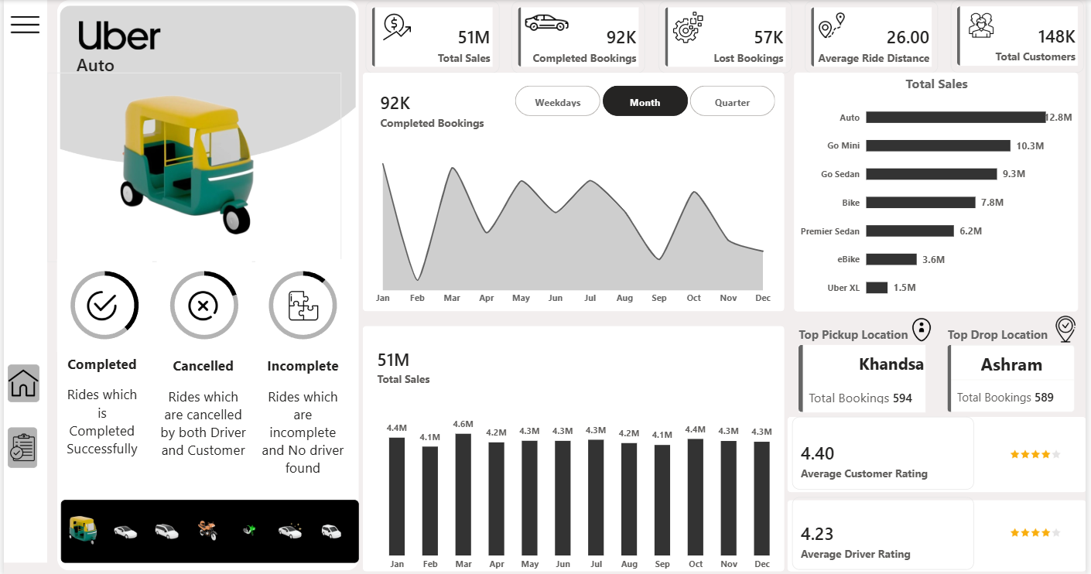
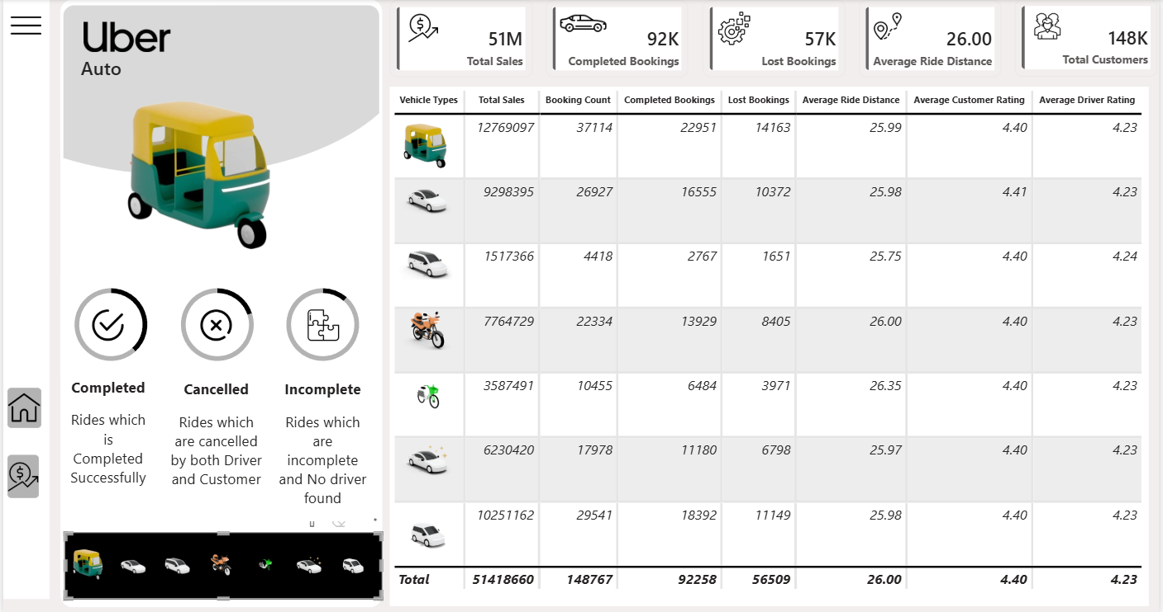
Insights
1.Completion vs Cancellation
- Insights
  - In overall bookings (~62%) of booking has completed. Remaining (~38%), bookings lost the opportunity
- Action
  - Since only 62% of bookings are completed and 38% are lost, improving the completion rate should be the top priority. The company should optimize driver allocation, improve supply during peak hours, and focus on high-demand locations to reduce lost opportunities.
2.Cancellation Analysis
- Insight
  - There is 47% of the cancellations initiated by the Driver. Followed by Cancelled by the customer and ‘No Driver Found’ are average 18% of cancellations.
  - 16% of them are in-completed rides
- Action
  - As 47% of cancellations are initiated by drivers, driver behavior needs to be addressed. Implementing a driver performance monitoring system, offering incentives for high acceptance rates, and introducing penalties for frequent cancellations can improve reliability.

3. Vehicle Type
- Insight
  - Auto Contributing 25% of the booking volume and revenue ratio
  - Go mini and Go Sedan following back with 20% of the total booking volume and revenue
  - EBike contributing 7% of the booking volume and Uber XL contribution with below 3%
- Action
  - The Auto segment contributes 25% of total booking volume and revenue, making it the most important vehicle type. Increasing Auto availability during peak hours and introducing customer loyalty offers can further strengthen revenue growth
  - Vehicle types such as eBike and Uber XL contribute low booking volume and revenue. The company can either promote these categories through targeted marketing campaigns or optimize fleet size to reduce operational costs.
4.Estimated Revenue Loss
- Insight
  - Found there is 1,17,68,007 Estimated revenue loss
  - 32% of Estimated revenue Loss by the Auto, Premier Sedan, eBike and Uber XL below 10% of the estimated revenue loss value
- Action
  - The estimated revenue loss of 1,17,68,007 is significant. Priority should be given to resolving “No Driver Found” issues in specific high-demand locations to recover lost revenue.
5.Quarter Wise
- Insight
  - 1st and 3rd quarter sales higher than 2nd and 4th quarter
  - There is a noticeable revenue hike in month of March and noticeable increasing month of January and October. Revenue decreasing month of February and September
  - However, month of January contains the higher Booking Volume of 12,855 and month of February and December booking volume is decreasing

- Action
  - Since the 1st and 3rd quarters perform better than the 2nd and 4th quarters, seasonal strategies such as promotional offers during low-performing months (February and September) can help balance revenue throughout the year.
6.Weekdays
- Insight
  - Weekend Saturday and Sunday revenue is significantly higher than weekdays. However, Monday has high booking volume
- Action
  - Revenue is higher on weekends, especially Saturday and Sunday. The company can introduce surge pricing, special weekend packages, or promotional offers to maximize profitability.
  - Monday shows high booking volume. Corporate ride plans or weekday subscription models can be introduced to capitalize on consistent weekday demand.
4.Time Segment
- Insight
  - Evening time booking higher in both Revenue and Booking volume
- Action
  - Evening time generates the highest booking volume and revenue. Driver shifts should be aligned with peak hours to ensure sufficient availability.
5. Location Cluster
No Driver Found
- Insight
  - Total 10401 rides cancelled due to ‘No driver Found’ in particular location
  - 121 cities had the cancellation with Mid Frequency as 51 to 65 cancellations rides
- Action
  - The 10,401 rides cancelled due to “No Driver Found” and mid-frequency cancellation cities (51–65 cancellations) should be analyzed in detail. Improving driver supply in these cities can significantly increase overall completion rates.

